**Brief Report:**

Xiangyue Jiao, Wendi Xie, Modric Yue, Tianqiao Zhang

**1. Outline**

We choose topic 5, refraction/dispersion simulator tool. This topic asks us to create a refraction and dispersion simulator tool which users can choose different optical elements/interfaces, different types of glass, different incident light source, and different incident angles. With the change of each input, the incident rays and outcoming rays on the figure will change correspondingly as well. The critical angle is computed. There is an error alert if the input angle exceeds the critical angle. One of the most significant functions of our GUI is enabling that the rays will change accordingly with the change of the inputs.

**2. User guide**

This is a refraction/dispersion simulator.

You can choose different optical elements/interfaces. Options include Air/Glass surface, Glass/Air surface, Plane parallel plate, 60-degree prism, and simple positive lens. The elements on the figure will automatically change when you change the elements by drop-down menu.

Same for optical glass, you can choose the glass you want from the drop-down menu. The refractive index of the glass will change accordingly.

Same for incident light sources, you can pick any source you like from the drop-down menu and the figure will show the rays corresponding to the source you choose.

Same for incident angles. Here you have two different ways to input the incident angle. You can either directly enter the incident angle you want in the “starting ray angle” box or drag the slider handle. The value of the angle will be shown in angle box when you drag the handle.

The critical angle box shows the critical angle according to your inputs. Any incident angle that is larger than the critical angle will trigger the error alert of the simulator. Please enter the angle smaller or equal to the critical angle.

If you have any question, feel free to contact the designers.

**3. Example guide**

Example 1:

Inputs:

|  |  |
| --- | --- |
| Interface type | Air/Glass Surface |
| Glass | N-BK7 |
| Incident ray angle | 30 degrees |
| Light Source | Red chromatic light |

Output:

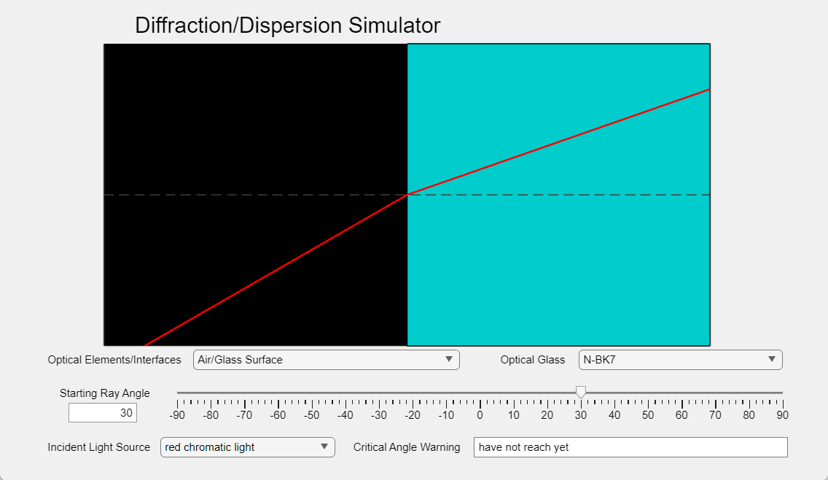

Example 2:

Inputs:

|  |  |
| --- | --- |
| Interface type | Air/Glass Surface |
| Glass | Calcium Fluoride (CaF2) |
| Incident ray angle | 60 degrees |
| Light Source | Yellow chromatic light |

Output:

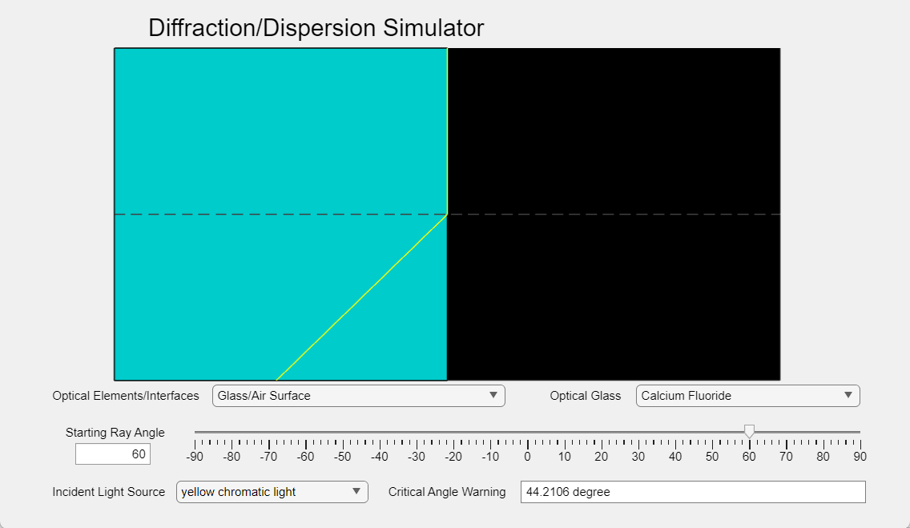

Here we choose and type in all the inputs in GUI and the window will output our yellow ray. This result is interesting because we can see that the refracted yellow light goes straight up. This is caused by the incident angle exceeding the critical angle which is generated by Snell’s law when the light travels from high RI (Glass) to low RI (air). We can see that if the incident angle exceeds the critical angle, the plot will stay at the critical angle and the right bottom box will display the critical angle.

Example 3:

Inputs:

|  |  |
| --- | --- |
| Interface type | 60-Degree Prism |
| Glass | N-F2 |
| Incident ray angle | 40 degrees |
| Light Source | white light |

Output:

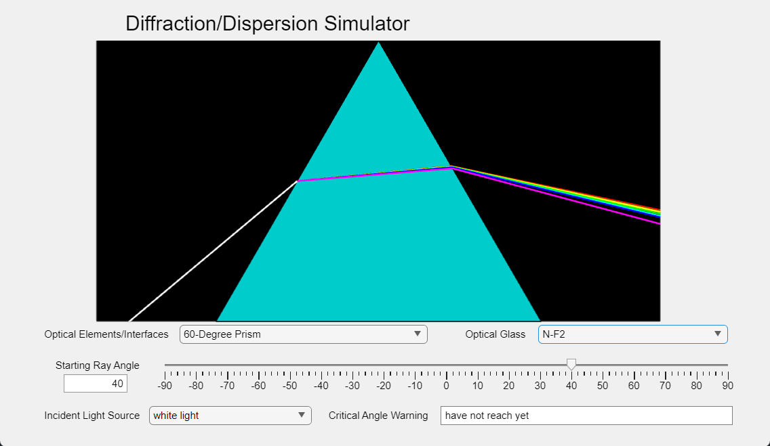

In this example, we choose to use a Dispersive Equilateral Prism made with N-F2 glass and shoot white light towards it at an angle of 40 degrees. This example is interesting because it clearly shows the effect of dispersion. Since white light consists of different monochromatic lights with different wavelengths, they will experience different RI inside the prism and thus will be refracted and travel at different angles. In this GUI we summarize the spectrum into seven colors: red, orange, yellow, green, cyan, blue, and magenta.

Example 4:

Inputs:

|  |  |
| --- | --- |
| Interface type | 60-Degree Prism |
| Glass | ZnSe |
| Incident ray angle | 40 degrees |
| Light Source | white light |

Output:

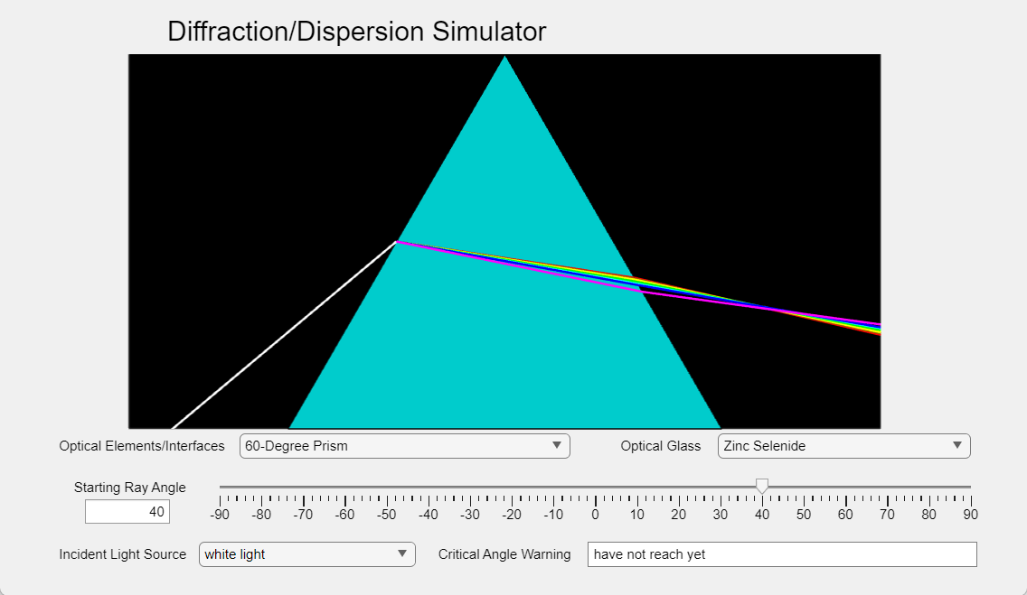

This time we switch the material from N-F2 to Zinc Selenide. This example is interesting because we can see that the directions of the lights are no longer diverging. They diverge in side the prism but converge when they go back into the air. This is because the refractive indices for the lights are higher for the lights traveling in Zinc Selenide than in N-F2, so the incident white light will be bent more and the refracted light in the prism will be negative (going down), Thus, the lights will be bent more upward if they have larger incident angle on the right side.

Example 5:

Inputs:

|  |  |
| --- | --- |
| Interface type | Simple Positive Lens |
| Glass | Barium Fluoride |
| Incident ray angle | 49.97080375967536 degrees |
| Light Source | white light |

Output:

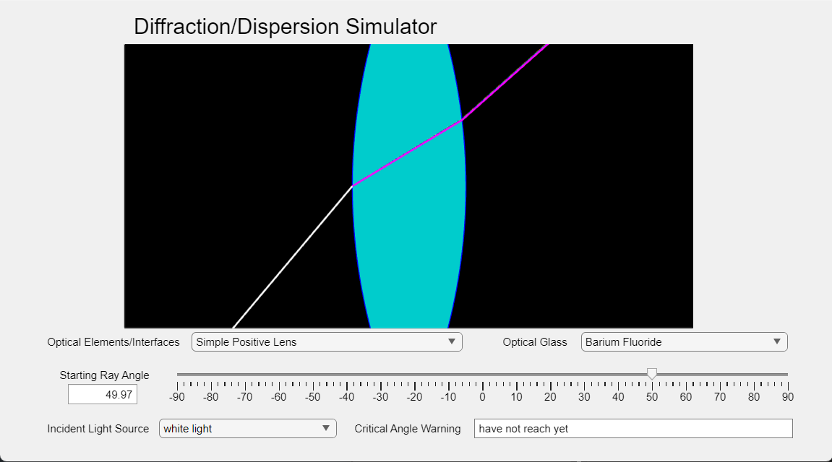

This time we shoot the white light towards a simple positive lens made of Barium Fluoride at an angle of 49.97080375967536 degrees. This example is interesting because it shows a very slight dispersion effect. The lights don’t scatter as much as we see in the previous example (with Zinc Selenide). This is because Barium Fluoride (v=81.78) has a larger Abbe number than Zinc Selenide (v=8.07). Larger Abbe number leads to smaller dispersion.